

ASSIGNMENT NO. 04

**Subject:**

**Cloud Computing**

**Submitted to:**

**Sir Rana Abu Bakar**

**Submitted by:**

**Aniqa Asim**

**Roll No:**

**BSIT-M2-19-26**

1. **WordPress in Ubuntu**

* **Backend of WordPress**

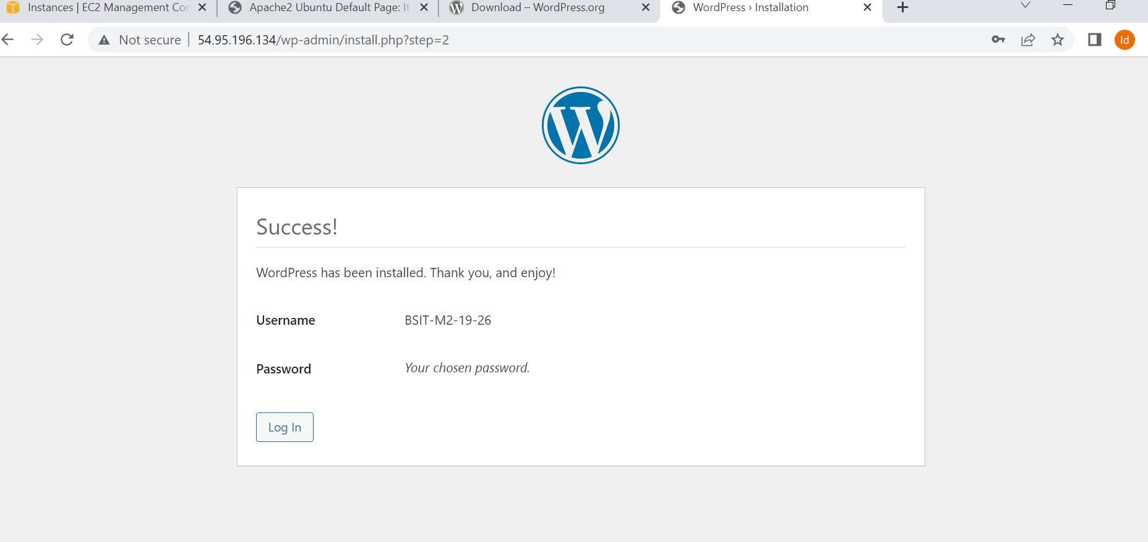

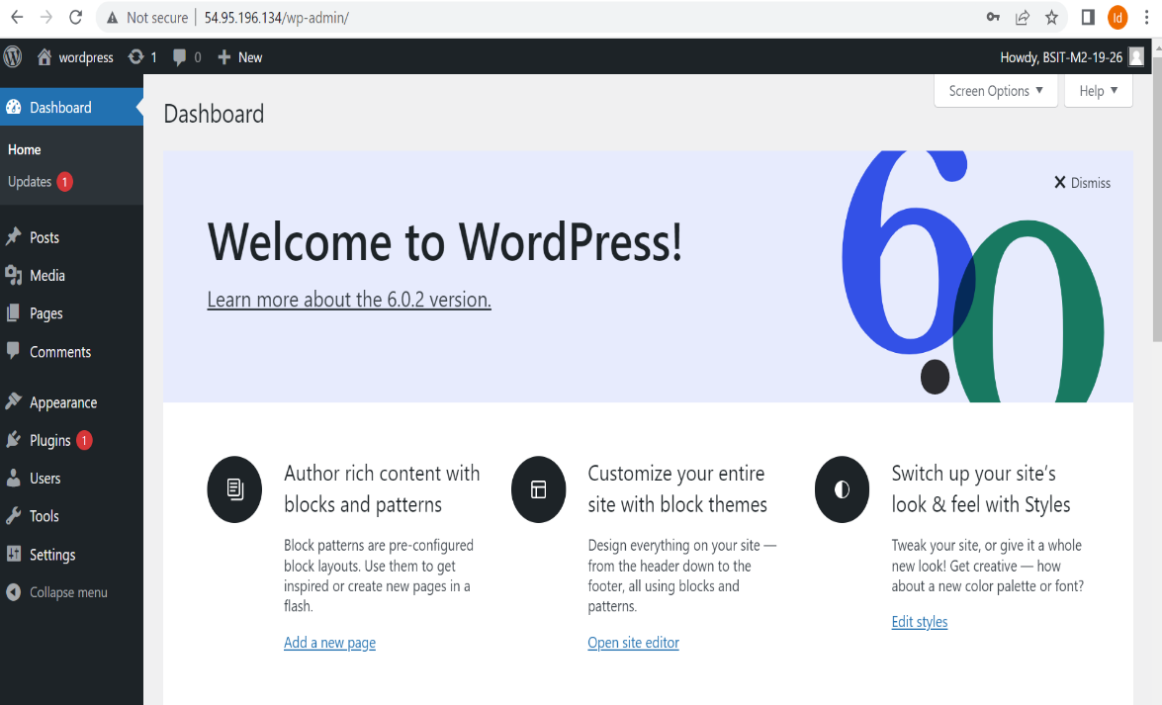

* **Frontend of WordPress**

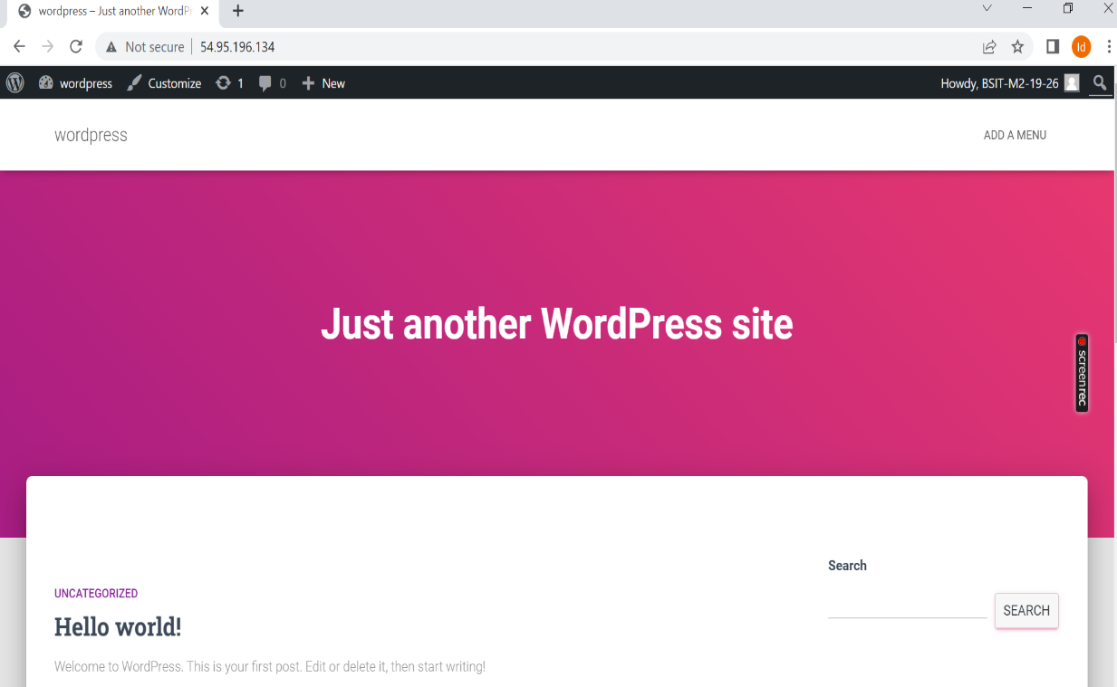

1. **ASP.net in Ubuntu**

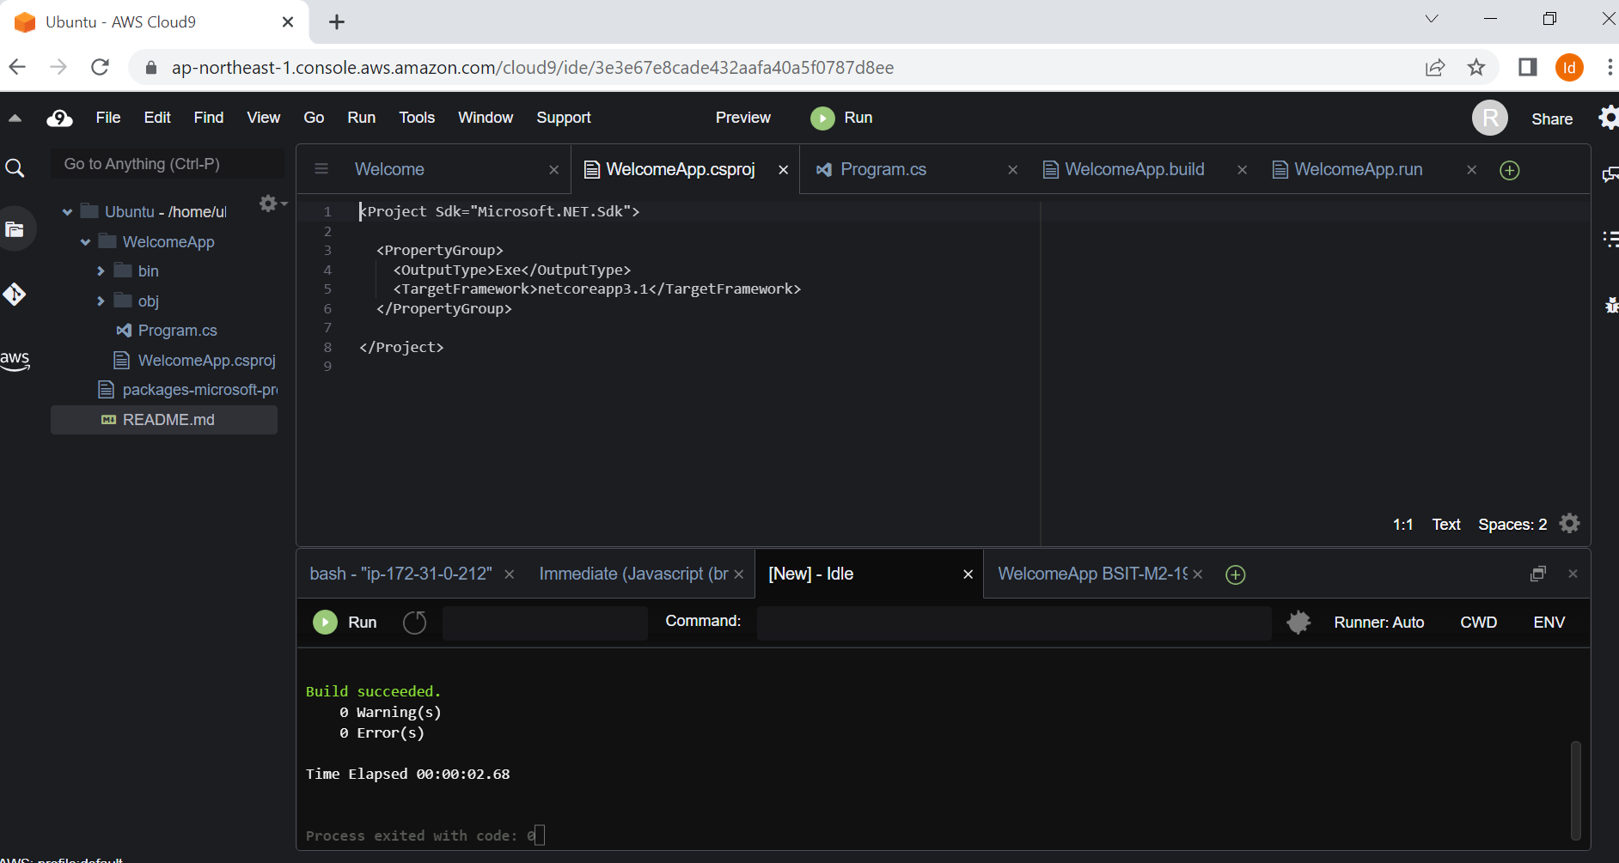

1. **Gig**



